Perimeter

Definition
# Source: AI Source: Provided by: [Data Path: Persons Table -> ID Column: 1, Name_En Column: Motasem Essam] -> From: [ChatGPT] on [7/20/2026]
In geometry, perimeter is the total length of the boundary surrounding a closed two-dimensional figure or region.
In simple terms:
Perimeter measures the distance all the way around a shape.
$$\boxed{\text{Perimeter}=\text{Total Length of the Boundary}}$$
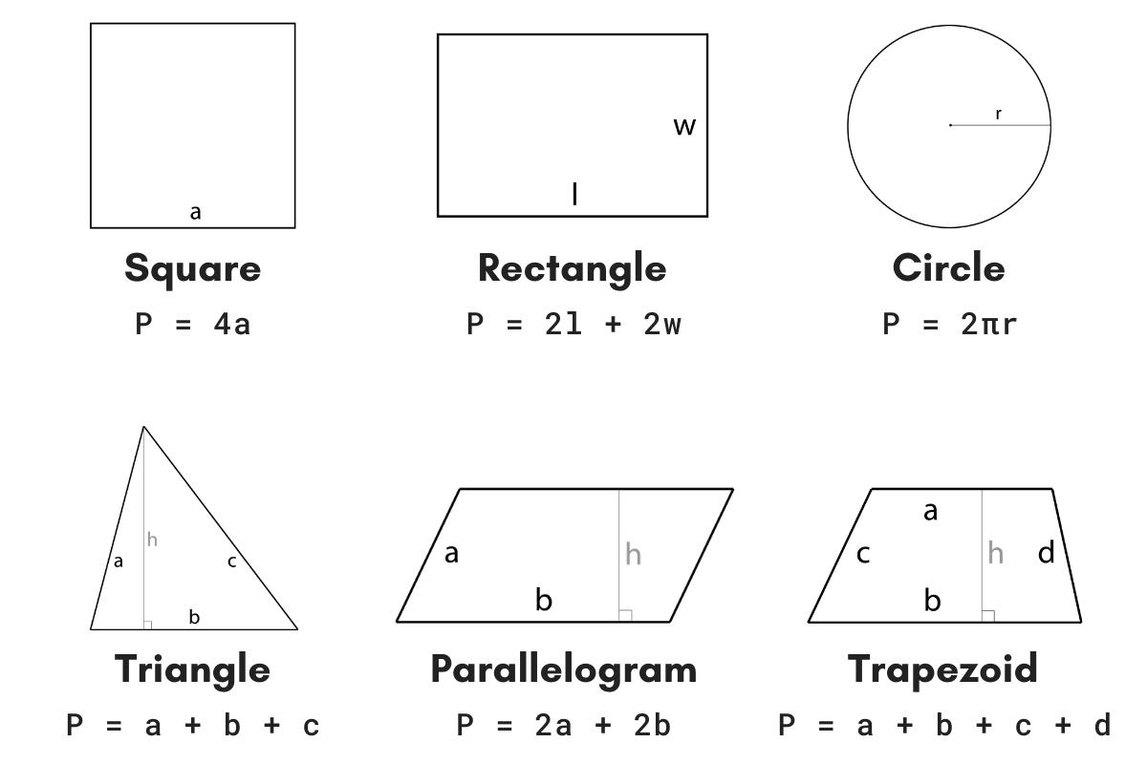
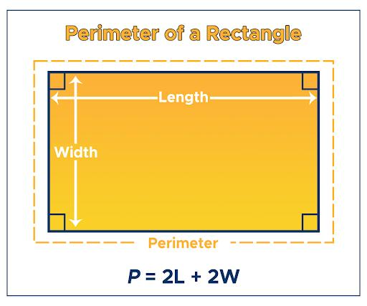
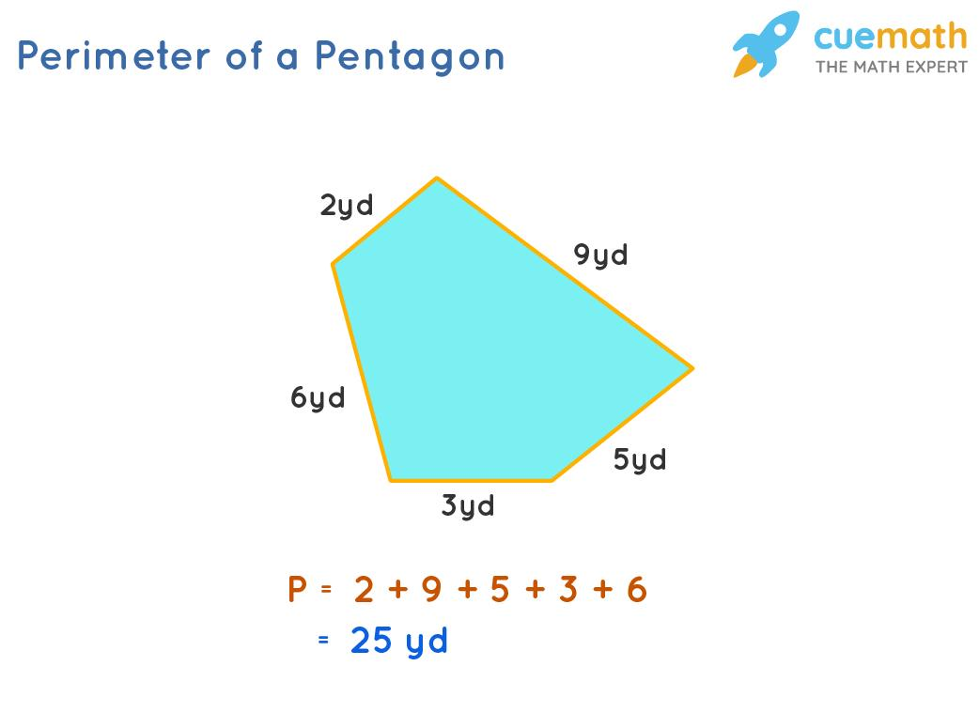
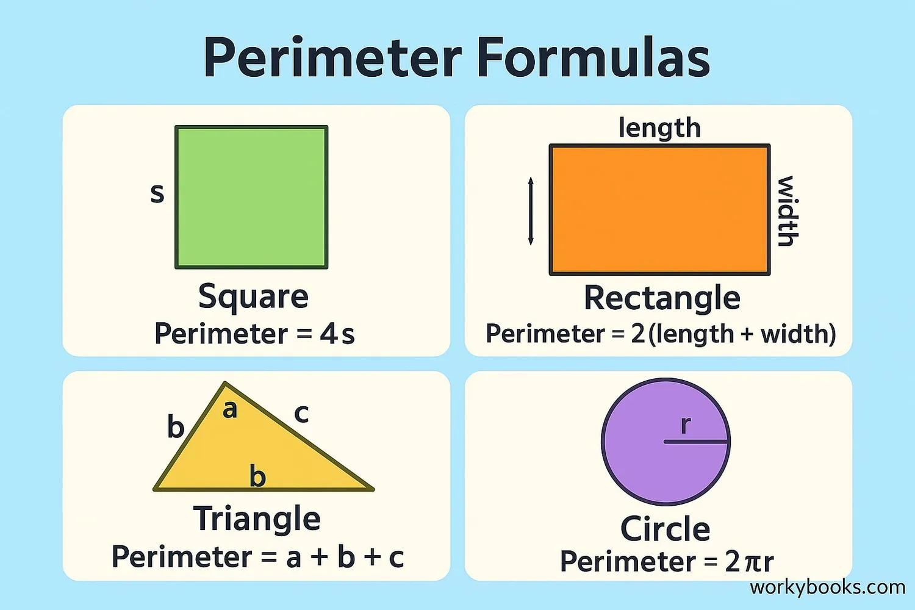
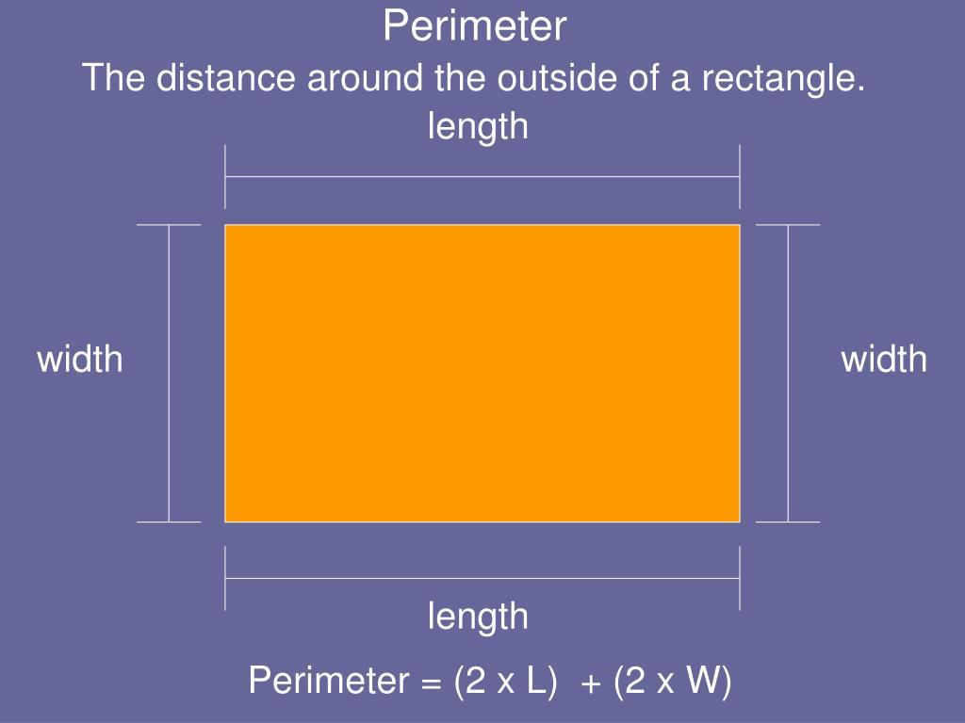
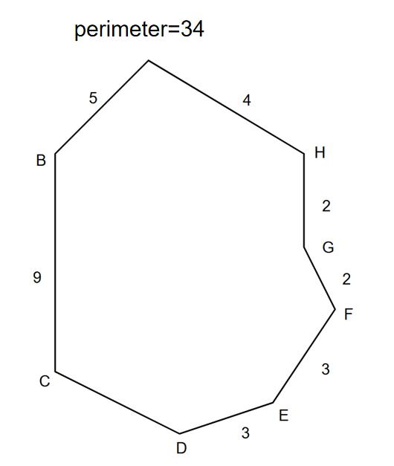

Characteristics
# Source: AI Source: Provided by: [Data Path: Persons Table -> ID Column: 1, Name_En Column: Motasem Essam] -> From: [ChatGPT] on [7/20/2026]
Perimeter:
- Measures a one-dimensional boundary.
- Is obtained by adding the lengths of the boundary segments or curves.
- Is associated primarily with closed plane figures.
- Is measured in linear units.
- Is always nonnegative.
- Is different from area, which measures the interior region.
$$\boxed{P≥0}$$
Its dimensional form is:
$$\boxed{\left[P\right]=L}$$

Perimeter of Common Geometric Shapes

1. Square
# Source: AI Source: Provided by: [Data Path: Persons Table -> ID Column: 1, Name_En Column: Motasem Essam] -> From: [ChatGPT] on [7/20/2026]
A square has four equal sides of length $s$:
$$\boxed{P=4s}$$
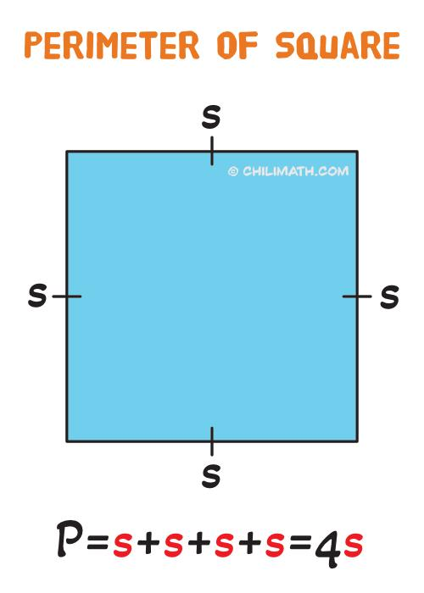
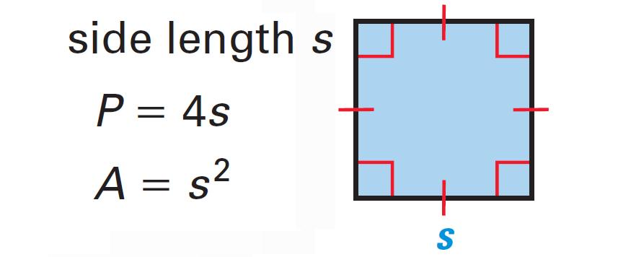
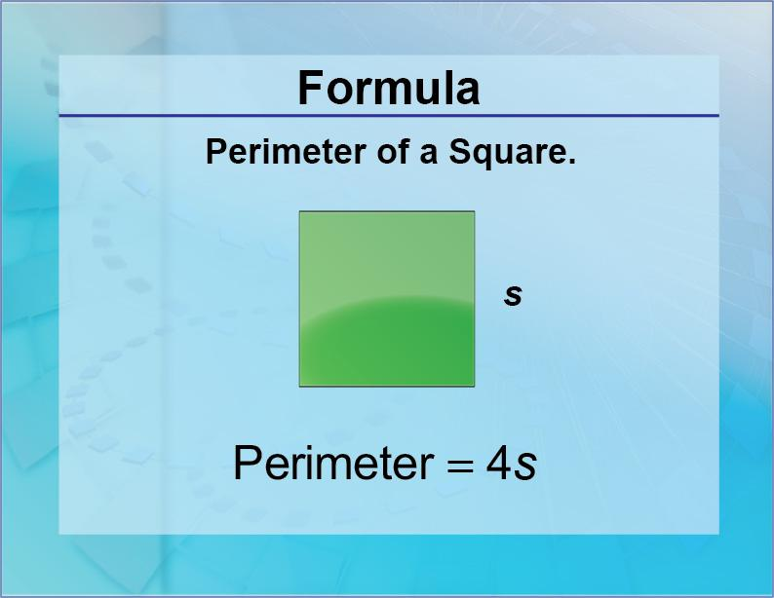
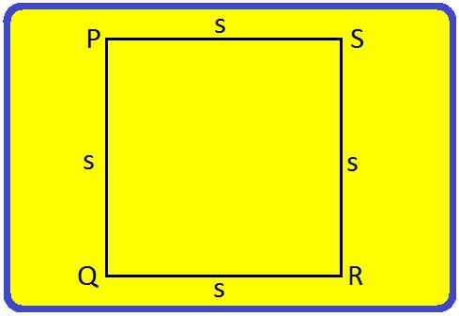
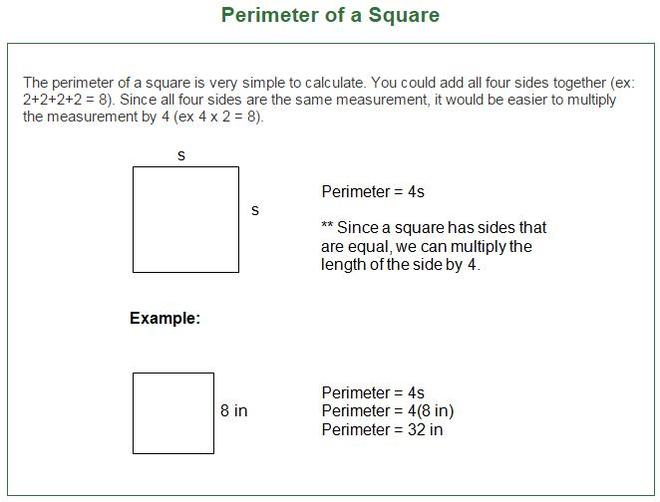

2. Rectangle
# Source: AI Source: Provided by: [Data Path: Persons Table -> ID Column: 1, Name_En Column: Motasem Essam] -> From: [ChatGPT] on [7/20/2026]
For a rectangle with length $l$ and width $w$:
$$\boxed{P=2\left(l+w\right)}$$


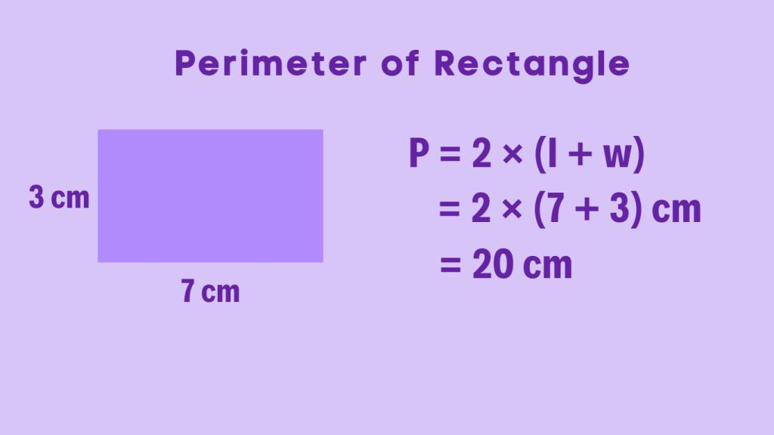
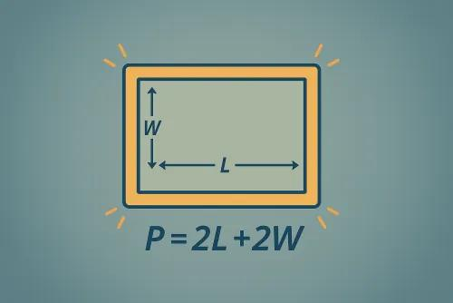
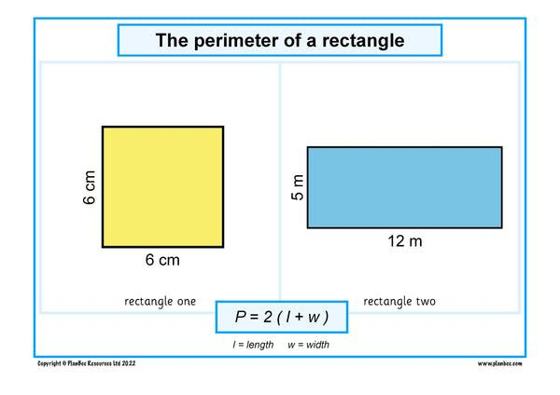

3. Triangle
# Source: AI Source: Provided by: [Data Path: Persons Table -> ID Column: 1, Name_En Column: Motasem Essam] -> From: [ChatGPT] on [7/20/2026]
For a triangle with side lengths $a$, $b$, and $c$:
$$\boxed{P=a+b+c}$$
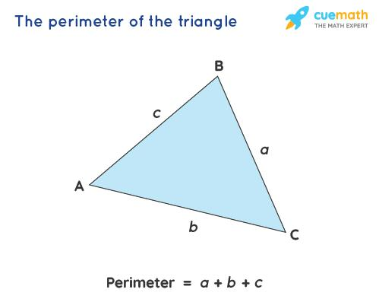
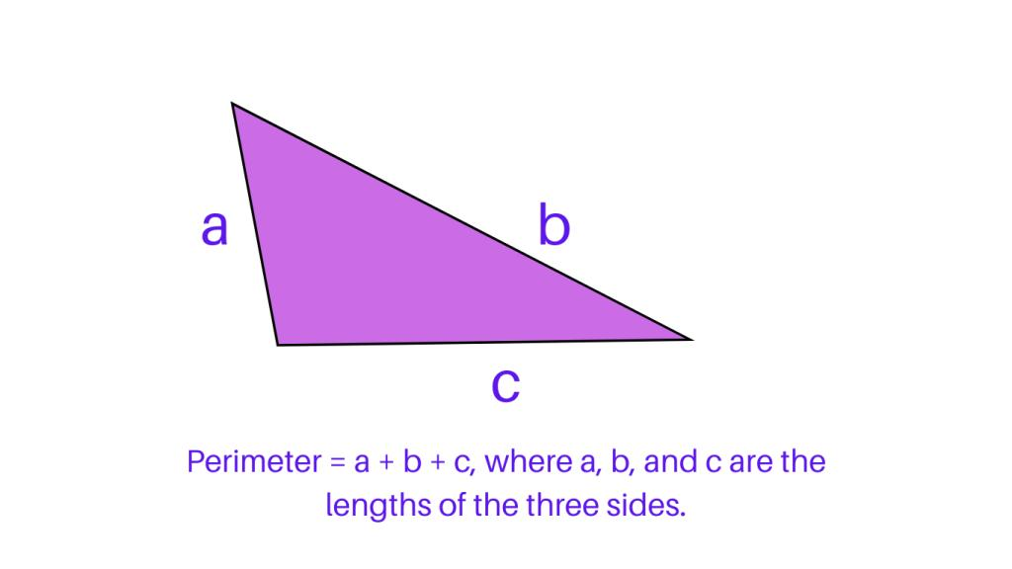
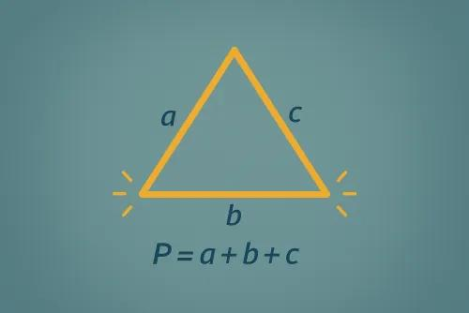
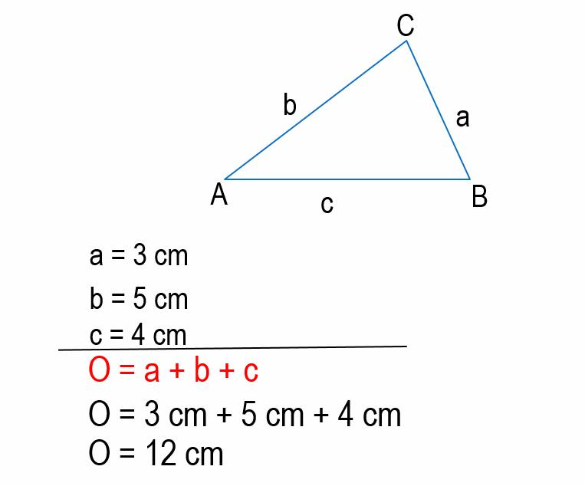
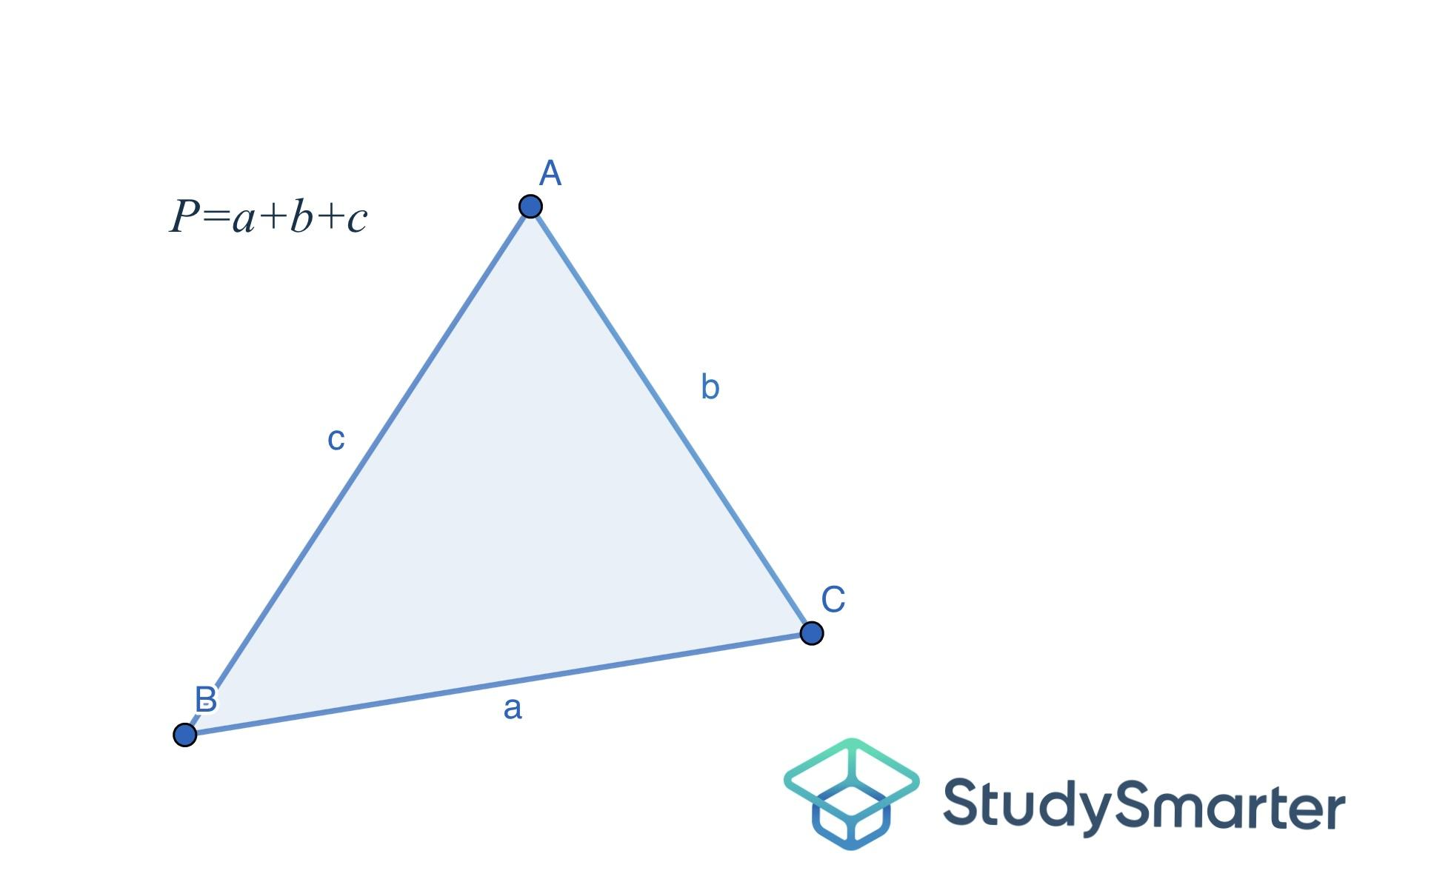

4. Regular Polygon
# Source: AI Source: Provided by: [Data Path: Persons Table -> ID Column: 1, Name_En Column: Motasem Essam] -> From: [ChatGPT] on [7/20/2026]
For a regular polygon with:
- $n$ sides
- side length $s$
the perimeter is:
$$\boxed{P=ns}$$
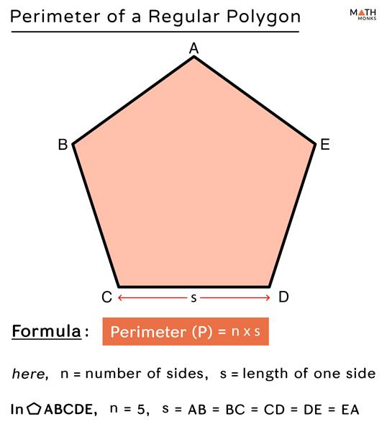
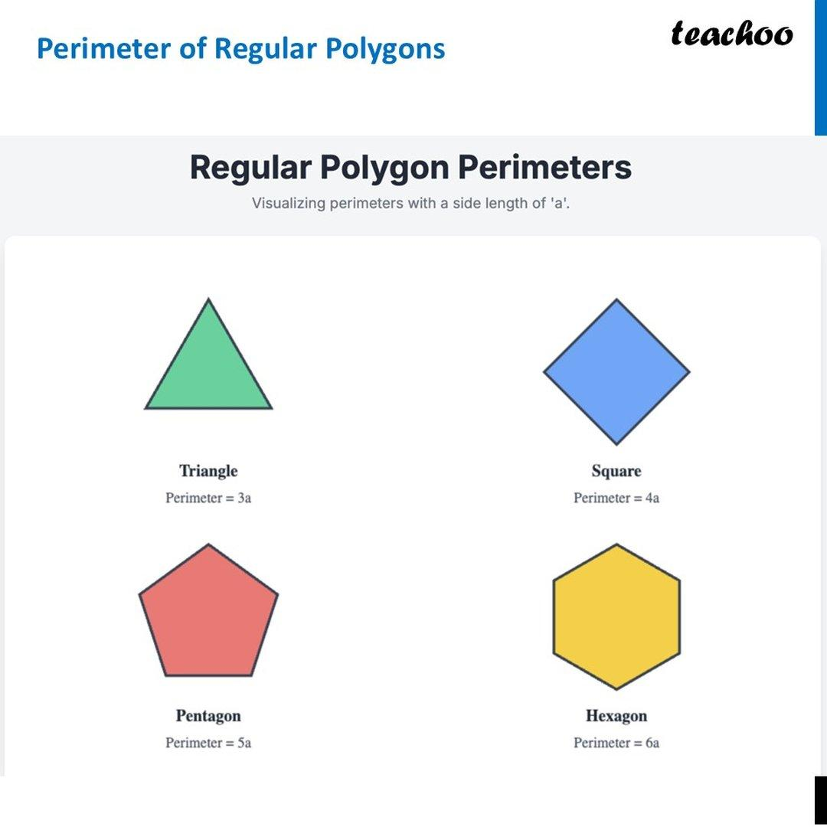
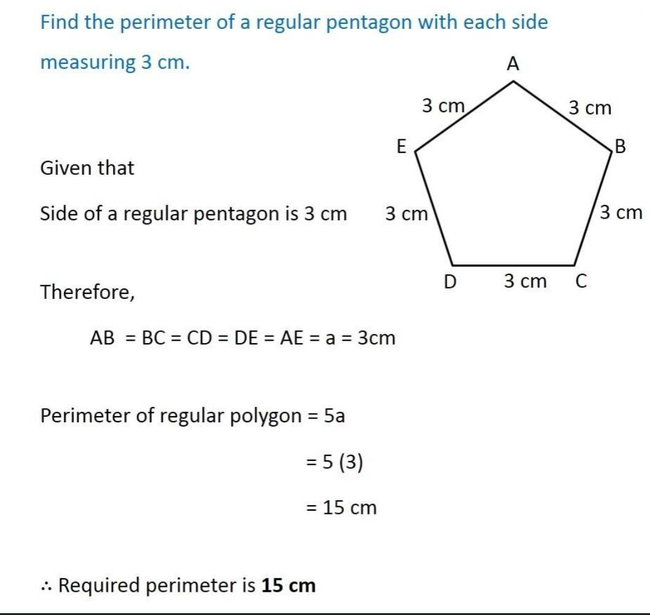
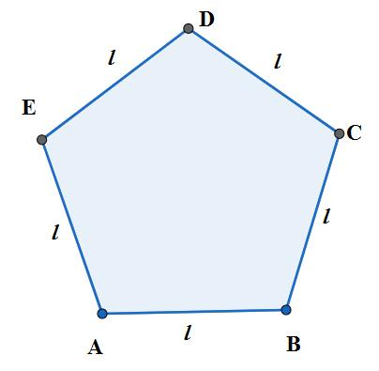
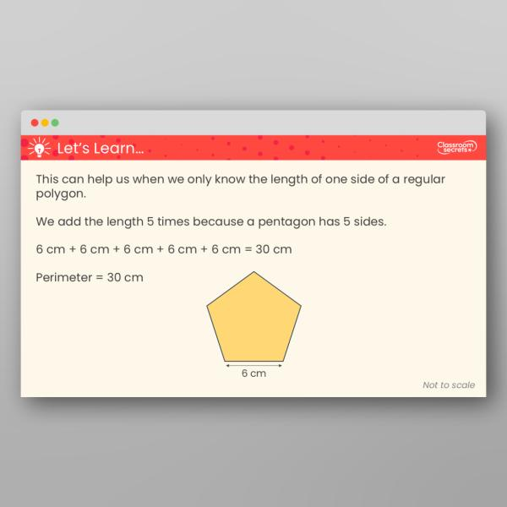
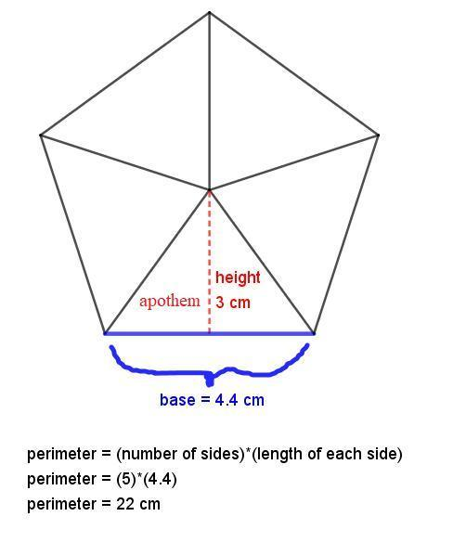

5. Irregular Polygon
# Source: AI Source: Provided by: [Data Path: Persons Table -> ID Column: 1, Name_En Column: Motasem Essam] -> From: [ChatGPT] on [7/20/2026]
For an irregular polygon, add the lengths of all sides:
$$\boxed{P=s_{1}+s_{2}+s_{3}+⋯+s_{n}}$$
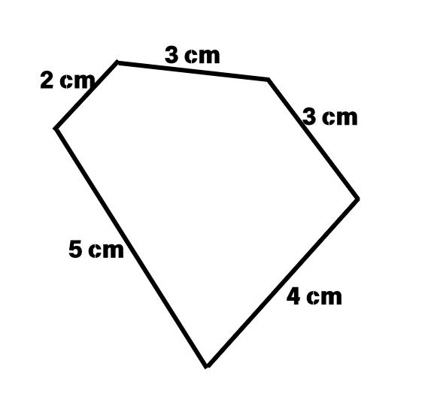
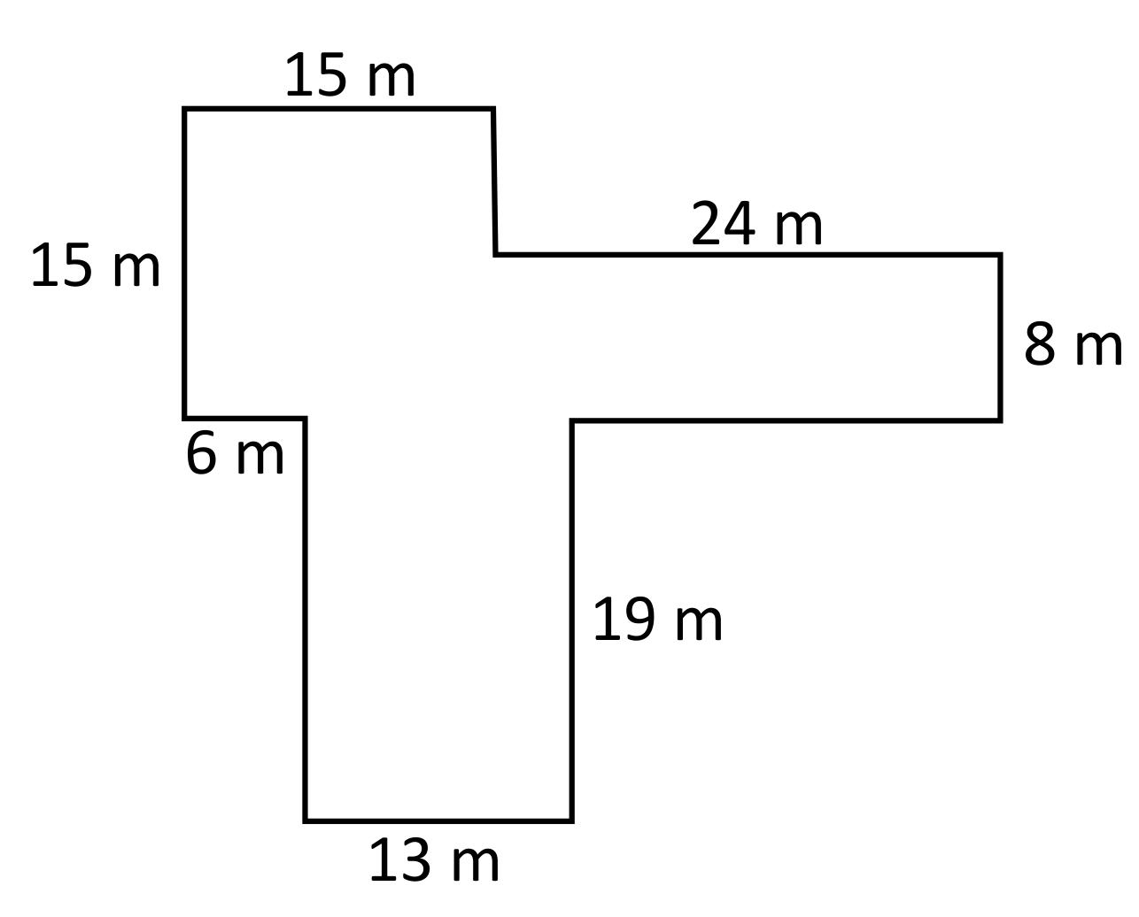
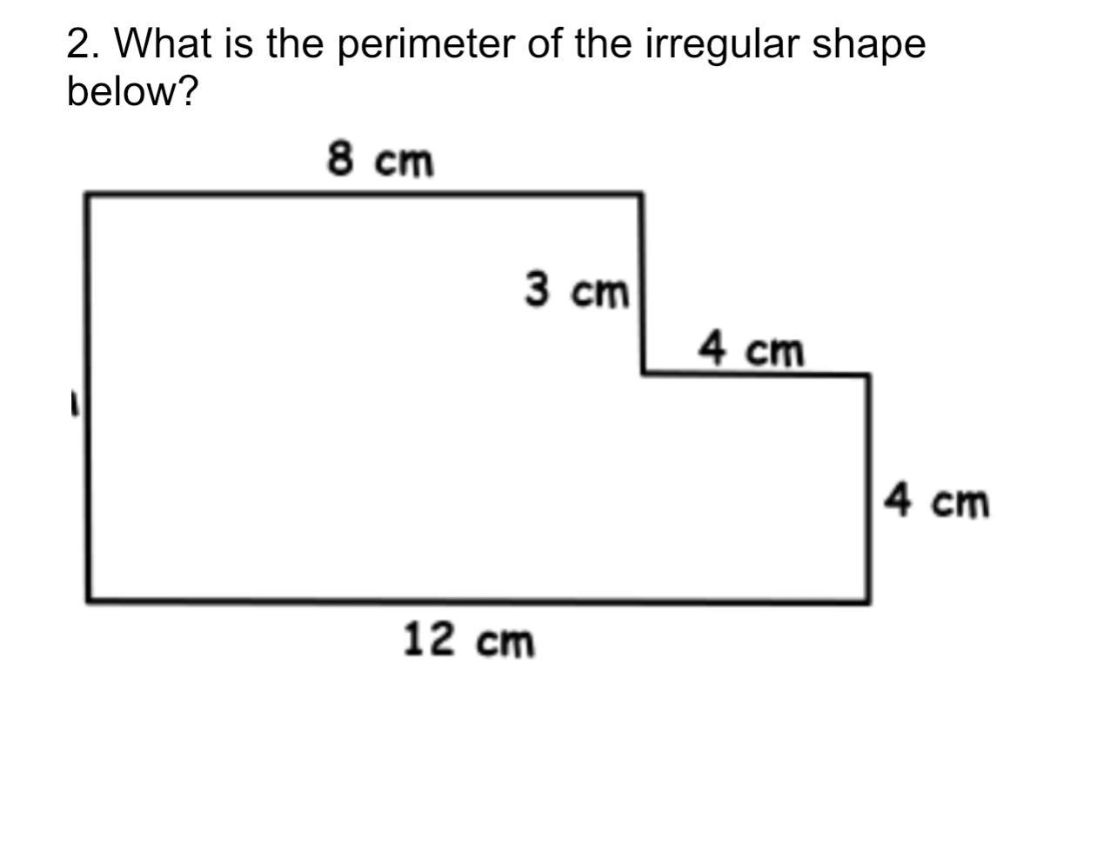
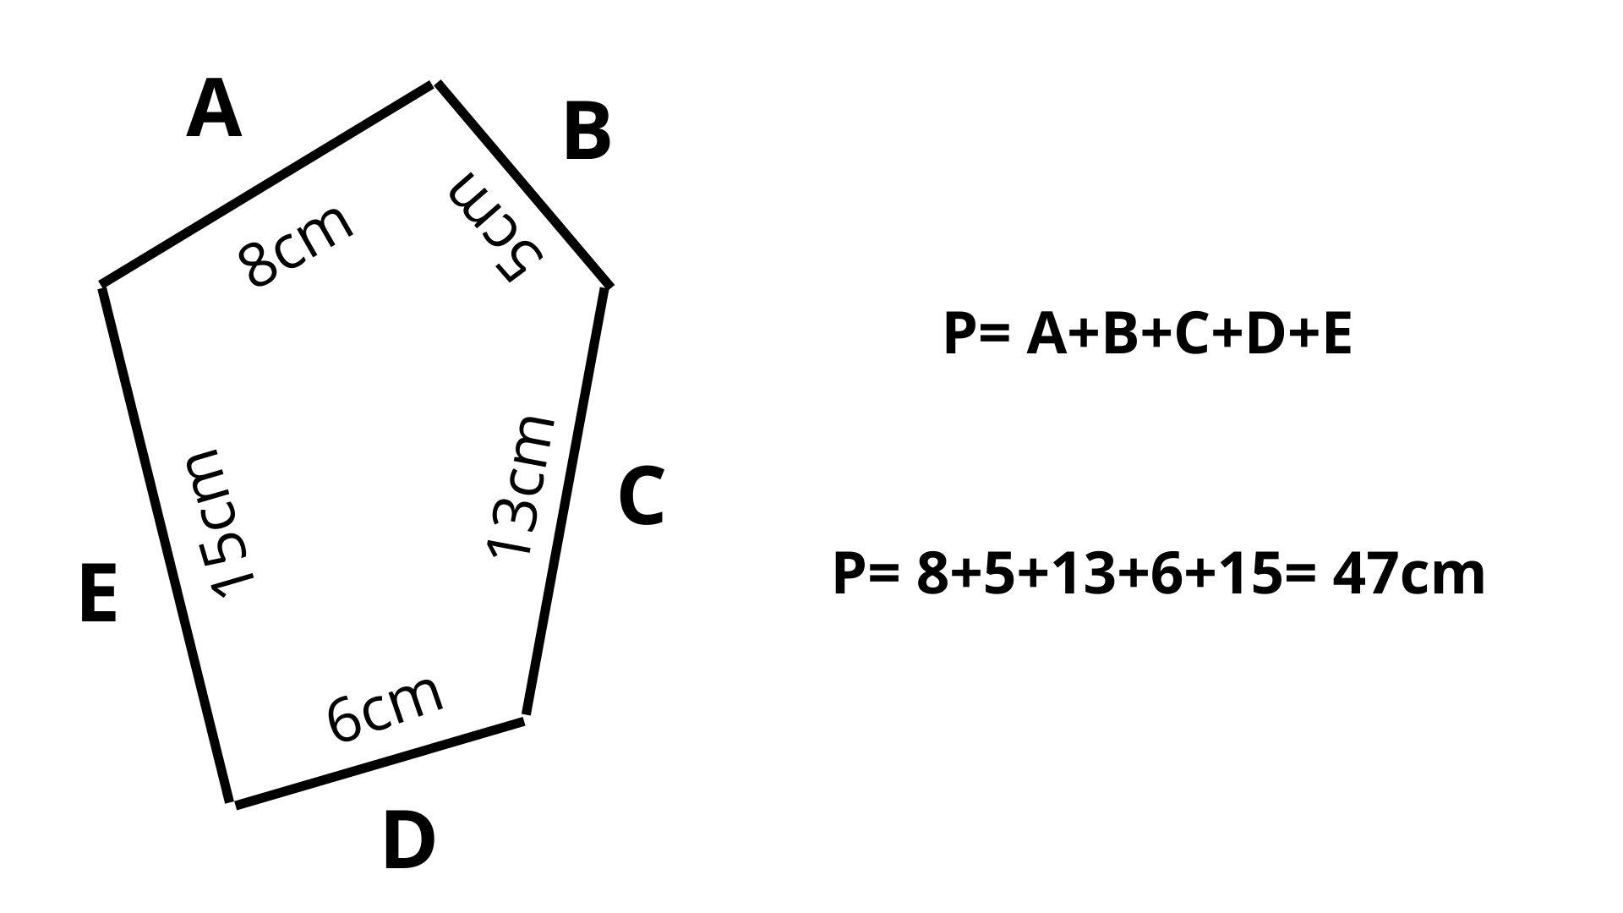
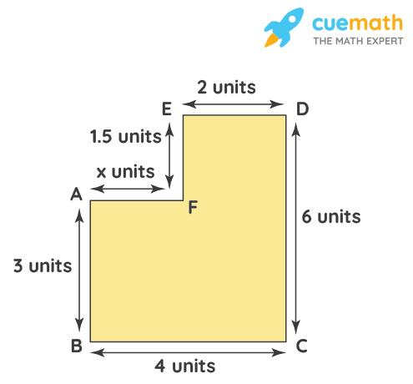
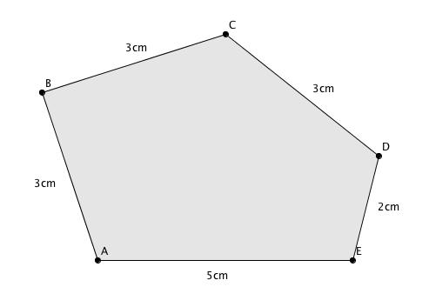
Unlike a regular polygon, the side lengths do not have to be equal.

6. Circle
# Source: AI Source: Provided by: [Data Path: Persons Table -> ID Column: 1, Name_En Column: Motasem Essam] -> From: [ChatGPT] on [7/20/2026]
For a circle, the perimeter is called the circumference.
$$\boxed{C=2πr}$$
or:
$$\boxed{C=πd}$$
where:
- $r$ = radius
- $d$ = diameter
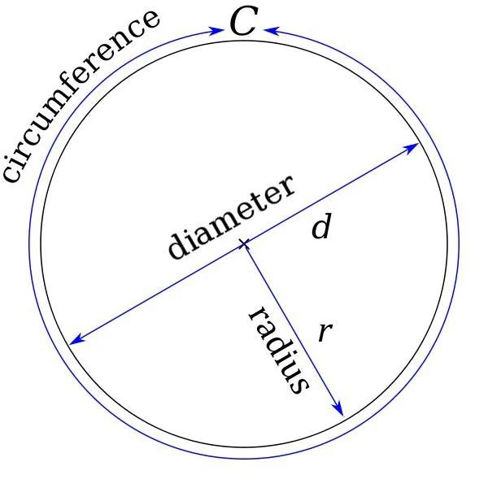
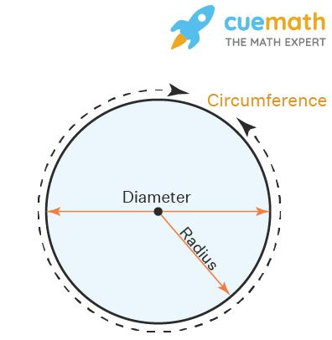
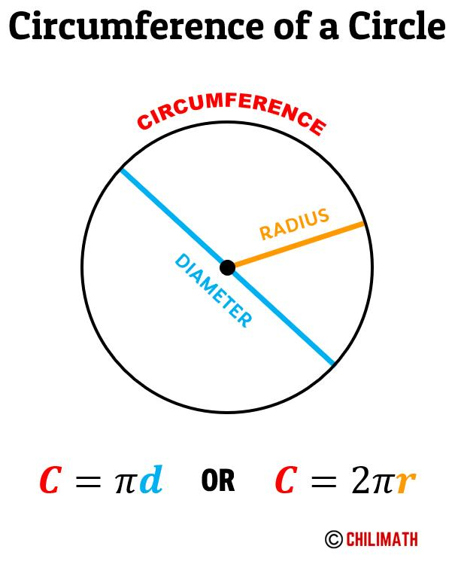
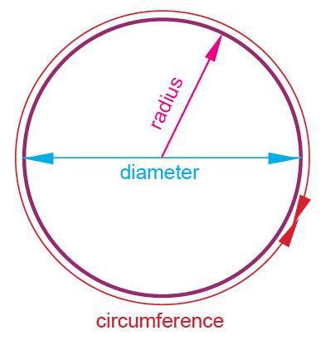
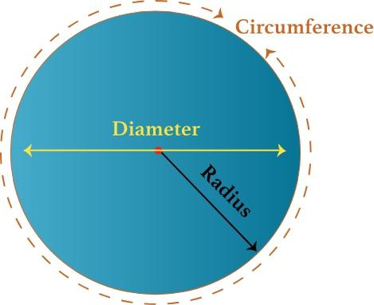

Perimeter and Boundary
# Source: AI Source: Provided by: [Data Path: Persons Table -> ID Column: 1, Name_En Column: Motasem Essam] -> From: [ChatGPT] on [7/20/2026]
The perimeter is directly related to the concept of a boundary.
$$\boxed{\text{Boundary}→\text{has a total length}→\text{Perimeter}}$$
For a closed polygon:
$$\boxed{P=\text{length of its entire boundary}}$$
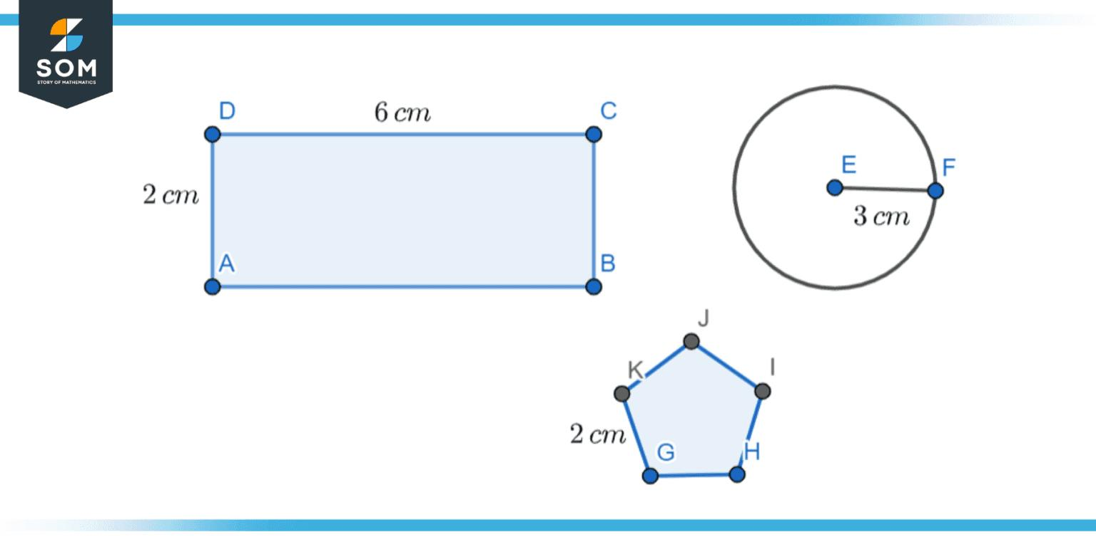
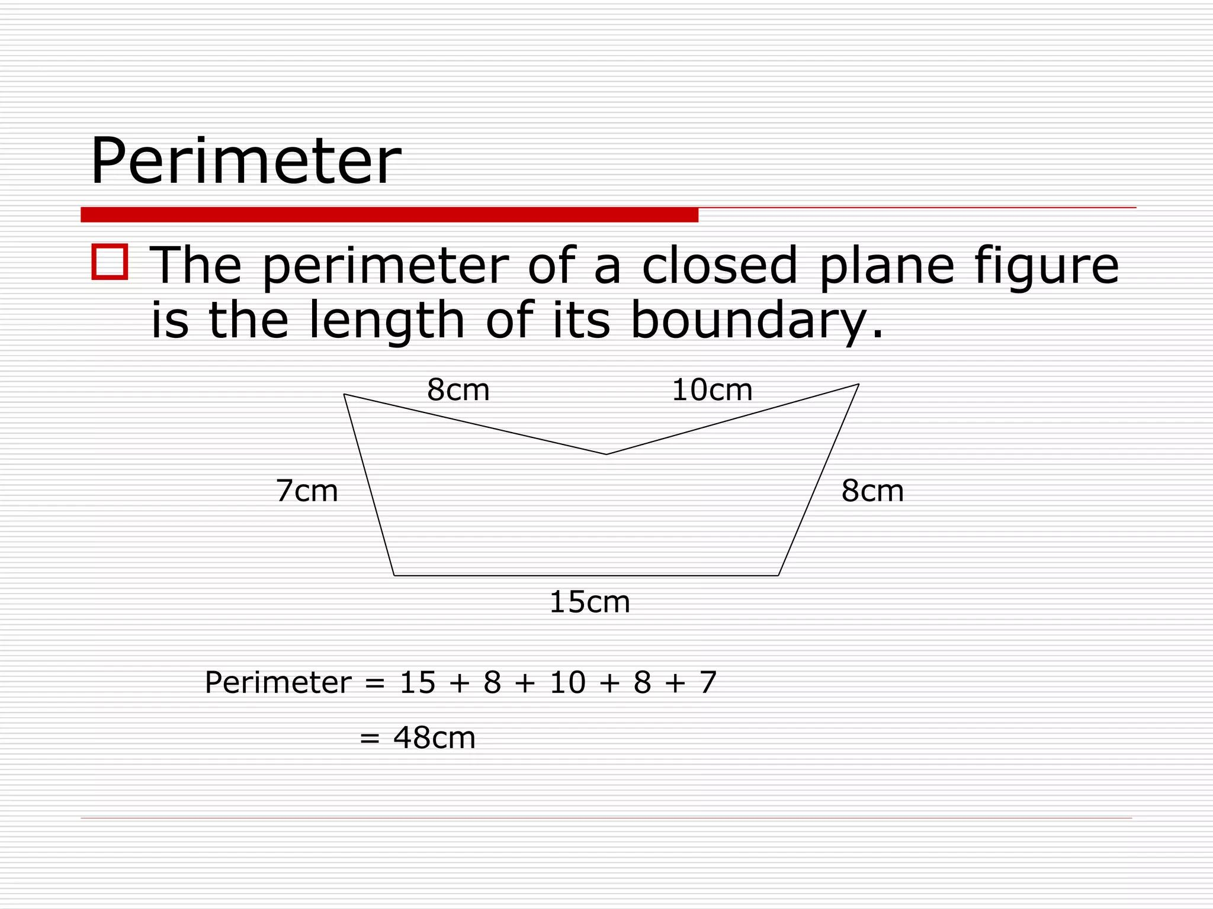
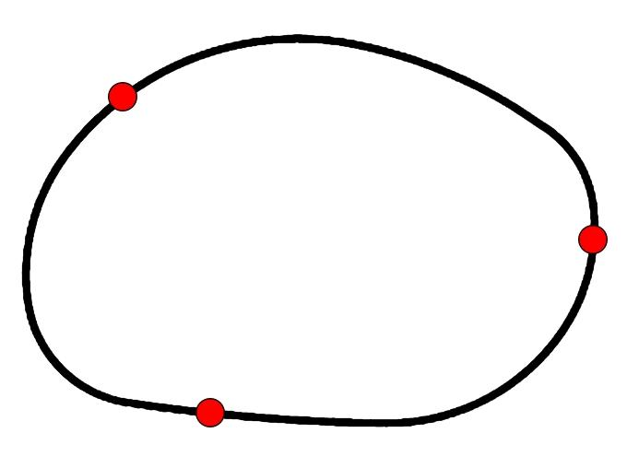
This fits naturally with your classification of closed shapes, closed curves, boundaries, and regions.

Perimeter vs. Area
# Source: AI Source: Provided by: [Data Path: Persons Table -> ID Column: 1, Name_En Column: Motasem Essam] -> From: [ChatGPT] on [7/20/2026]
These concepts should be kept clearly separate.
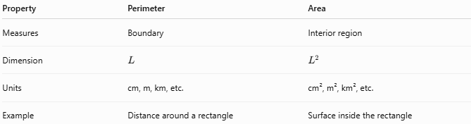
Property | Perimeter | Area
Measures | Boundary | Interior region
Dimension | $$L$$ | $$L^{2}$$
Units | cm, m, km, etc. | cm², m², km², etc.
Example | Distance around a rectangle | Surface inside the rectangle
For a rectangle:
$$\boxed{P=2\left(l+w\right)}$$
while:
$$\boxed{A=lw}$$
Therefore:
$$\boxed{\text{Perimeter}≠\text{Area}}$$
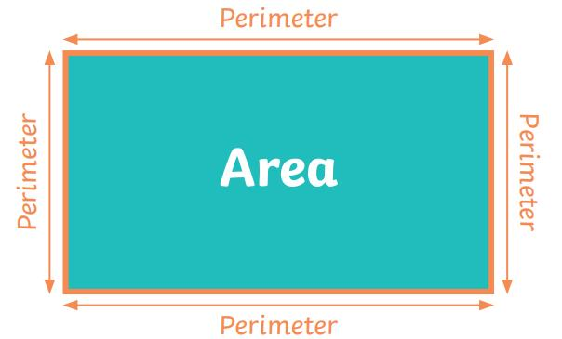
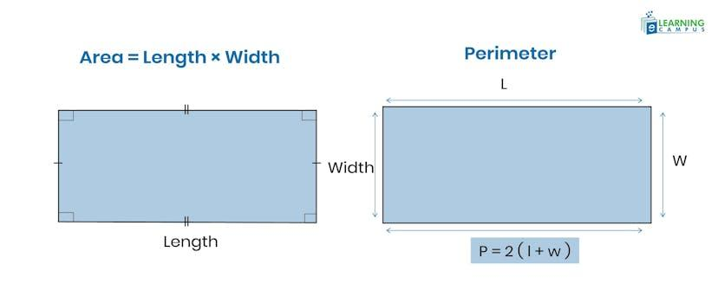
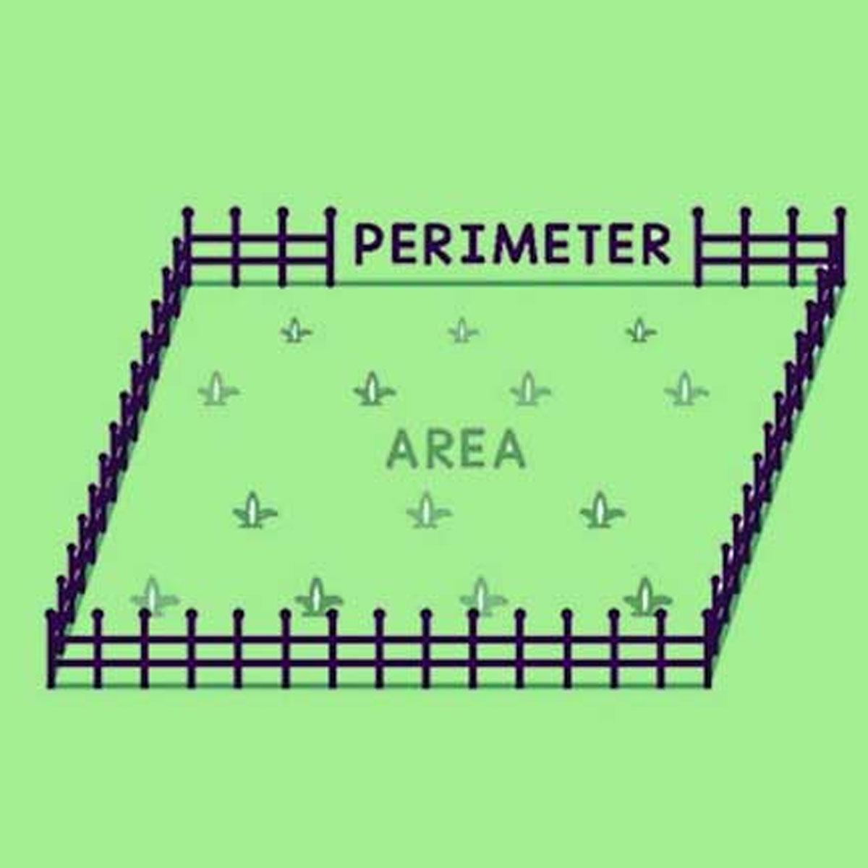
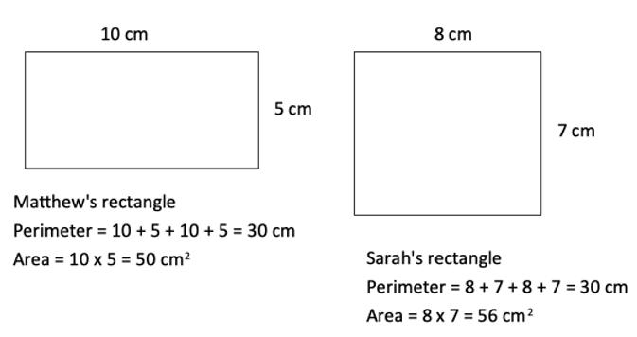
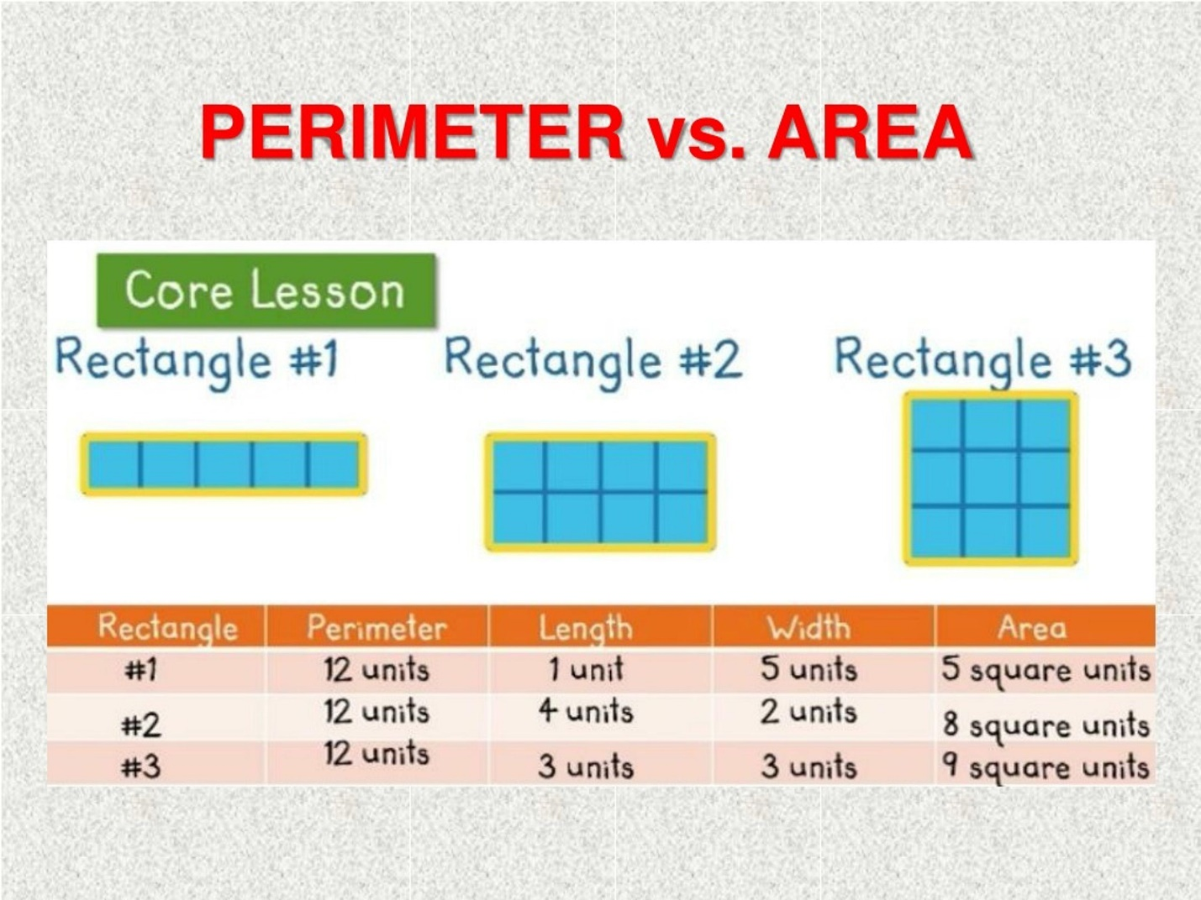

Perimeter vs. Length
# Source: AI Source: Provided by: [Data Path: Persons Table -> ID Column: 1, Name_En Column: Motasem Essam] -> From: [ChatGPT] on [7/20/2026]
Length is a measurement of one linear dimension or segment.
Perimeter is the sum of all boundary lengths of a closed figure.
For example:
$$\text{One side length}=5\text{ cm}$$
but for a square:
$$P=4\left(5\right)=20\text{ cm}$$
Thus:
$$\boxed{\text{Perimeter}=\sum{\text{ boundary lengths}}}$$

Perimeter of Composite Shapes
# Source: AI Source: Provided by: [Data Path: Persons Table -> ID Column: 1, Name_En Column: Motasem Essam] -> From: [ChatGPT] on [7/20/2026]
For a composite figure, the perimeter consists only of the outside boundary.
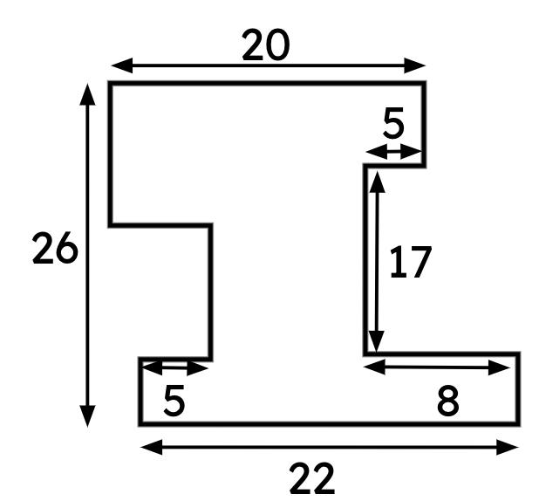
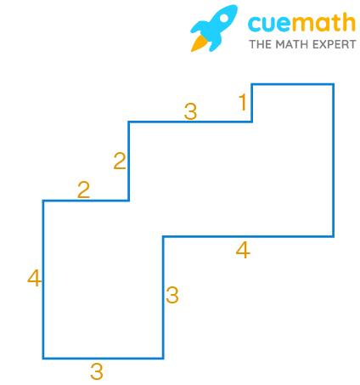
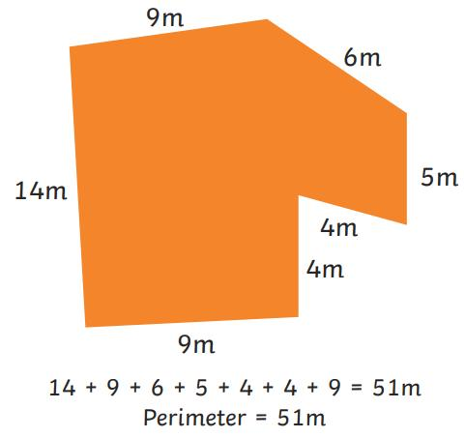
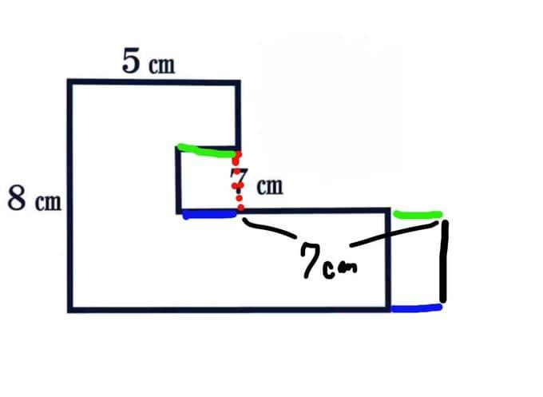
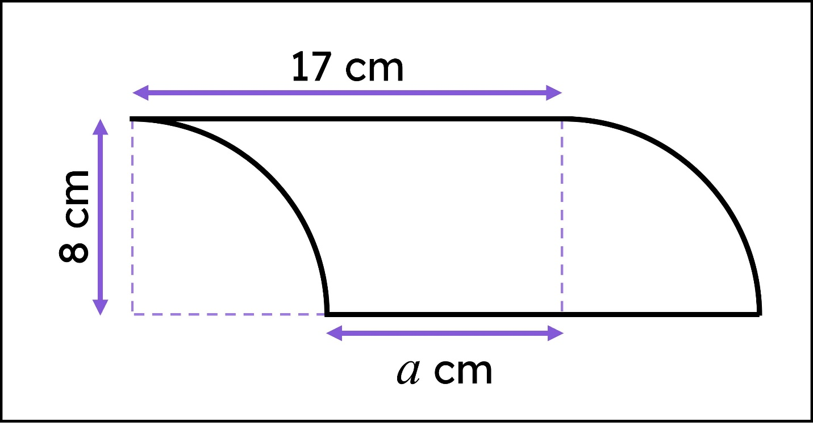
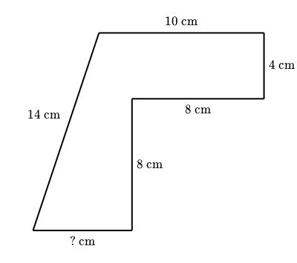
An internal line separating two parts of a composite shape is not normally included in the perimeter.
For example:
$$\boxed{P=s_{1}+s_{2}+⋯+s_{n}}$$
where the $s_{i}$ are the lengths of the external boundary segments.

Perimeter of Curved Boundaries
# Source: AI Source: Provided by: [Data Path: Persons Table -> ID Column: 1, Name_En Column: Motasem Essam] -> From: [ChatGPT] on [7/20/2026]
Perimeter is not limited to straight-sided polygons.
For a region with curved boundaries, the boundary length can involve arc length.
For a circle:
$$P=C=2πr$$
For a general parametric curve:
$$x=x\left(t\right), y=y\left(t\right)$$
the boundary length is:
$$\boxed{L=\int_{a}^{b}{\sqrt{{\left(\frac{dx}{dt}\right)}^{2}+{\left(\frac{dy}{dt}\right)}^{2}}}dt}$$
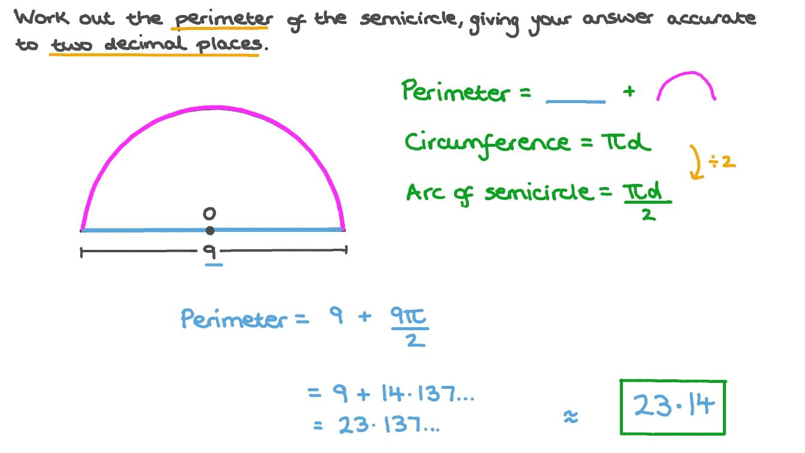
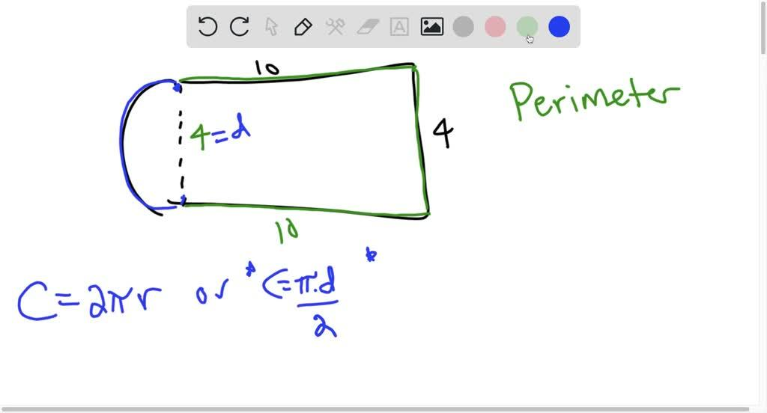
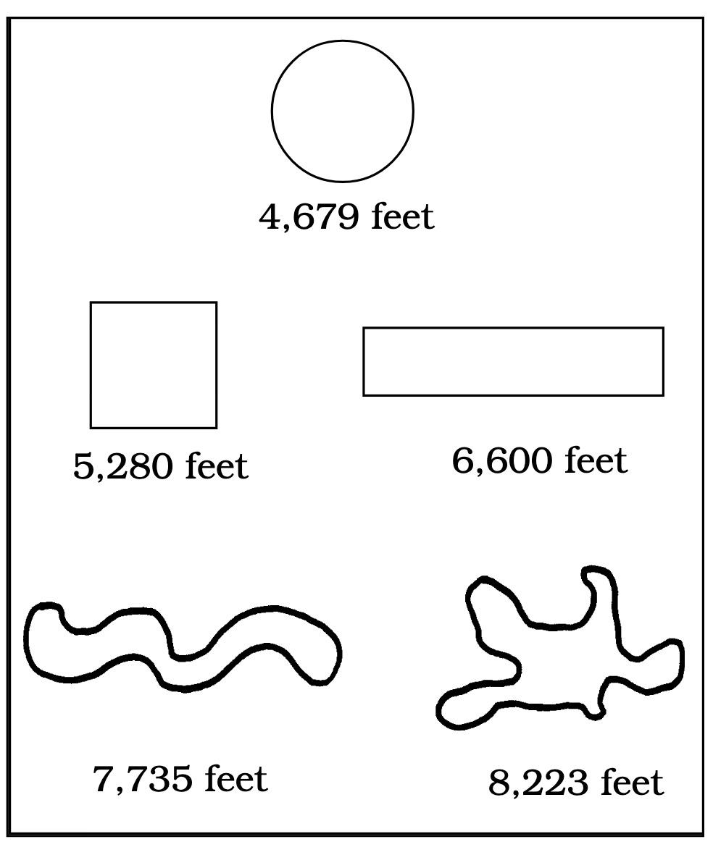
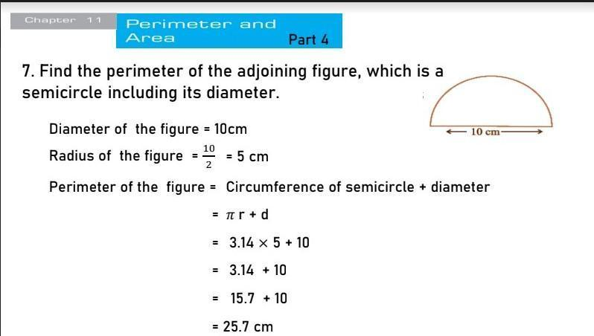
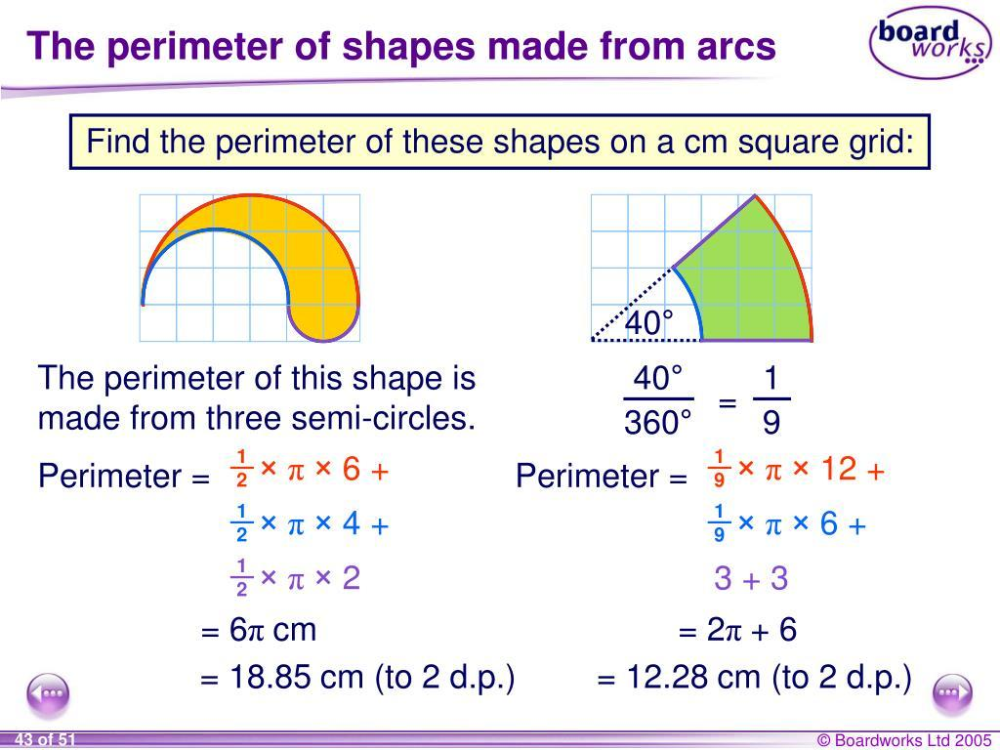

Perimeter of Irregular Regions
# Source: AI Source: Provided by: [Data Path: Persons Table -> ID Column: 1, Name_En Column: Motasem Essam] -> From: [ChatGPT] on [7/20/2026]
For an irregular closed region, the perimeter is the total length of its entire boundary.
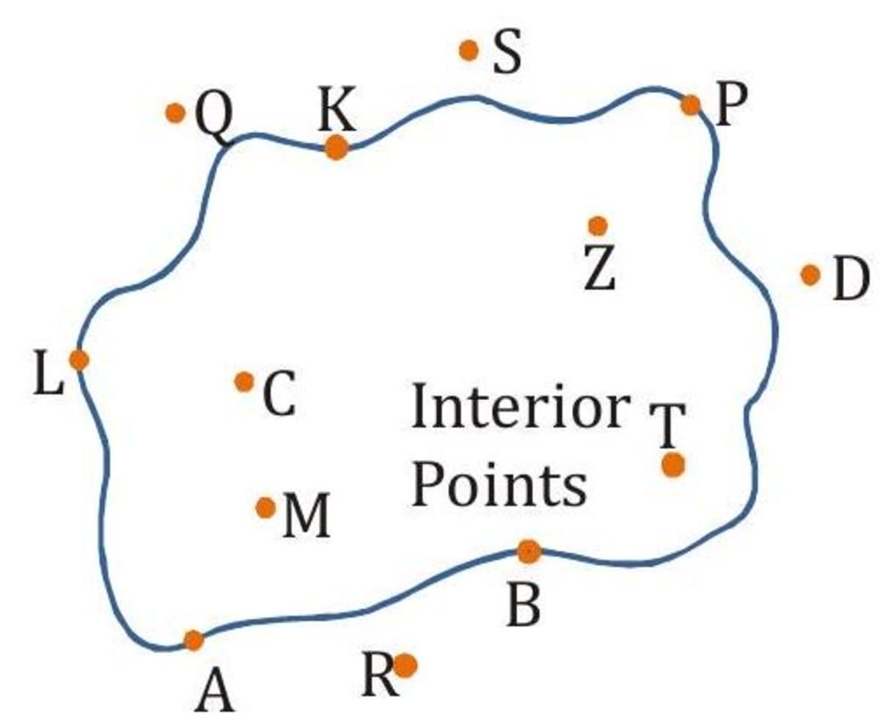

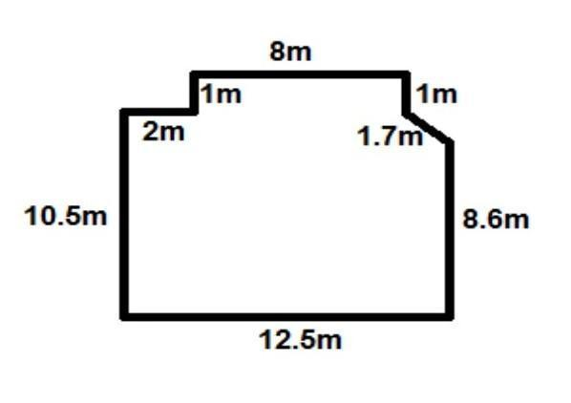
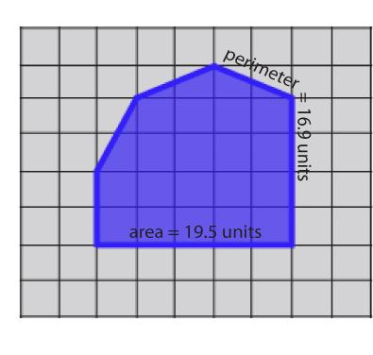
If the boundary consists of multiple segments and curves:
$$\boxed{P=L_{1}+L_{2}+⋯+L_{n}}$$
where each $L_{i}$ is a boundary component.

Perimeter and Open Shapes
# Source: AI Source: Provided by: [Data Path: Persons Table -> ID Column: 1, Name_En Column: Motasem Essam] -> From: [ChatGPT] on [7/20/2026]
An open curve does not normally have an enclosed-region perimeter because it does not form a closed boundary.
For example:
$$P_{\text{start}}≠P_{\text{end}}$$
means the curve is open.
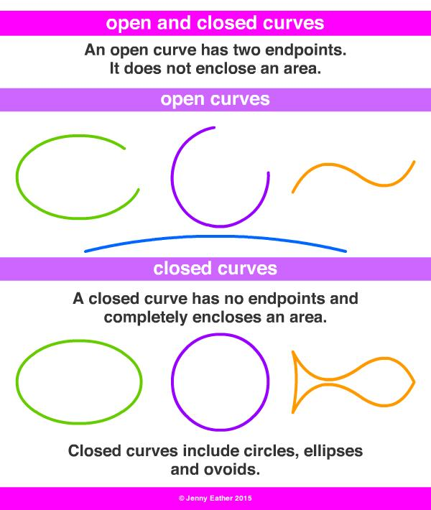
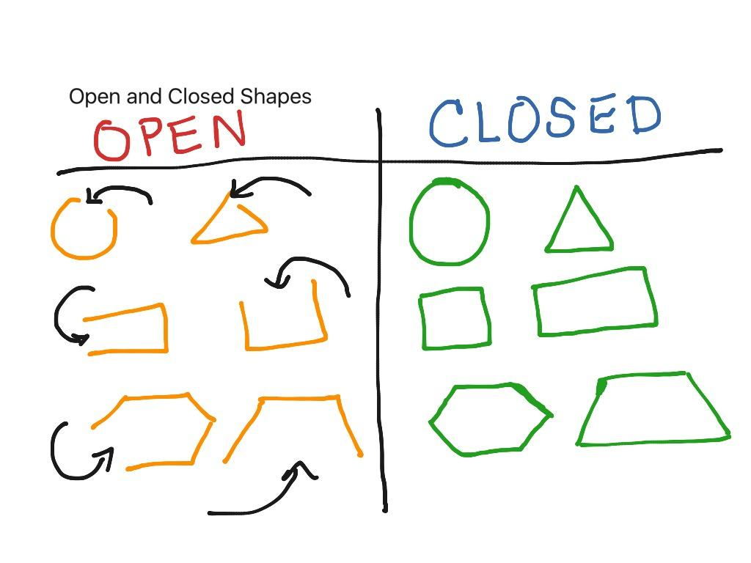
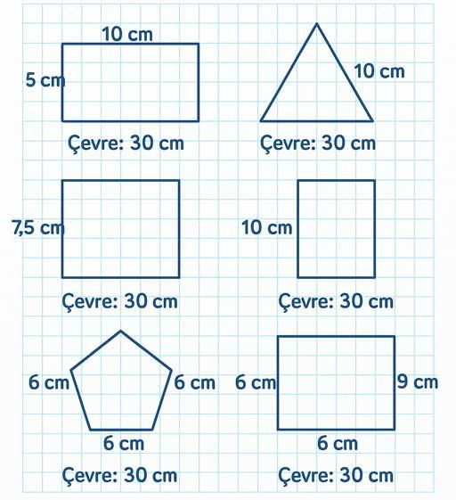
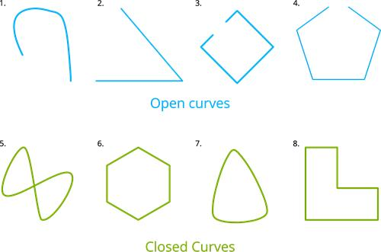
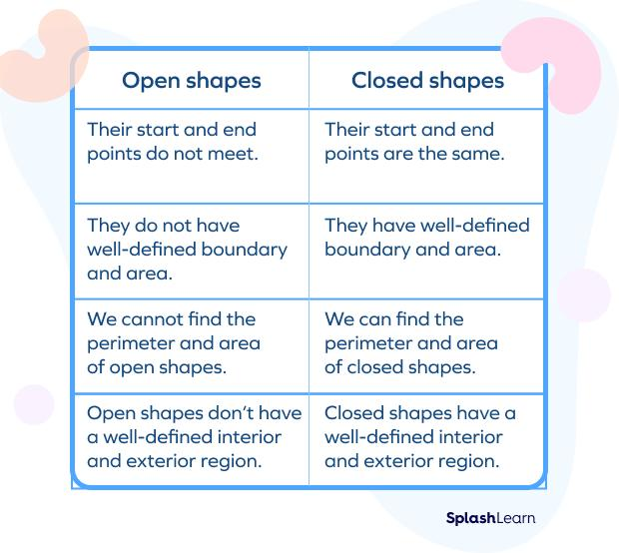
However, the length of the open curve can still be measured.
So it is useful to distinguish:
$$\boxed{\text{Open Curve}→\text{Curve Length}}$$
from:
$$\boxed{\text{Closed Boundary}→\text{Perimeter}}$$

Perimeter and Scaling
# Source: AI Source: Provided by: [Data Path: Persons Table -> ID Column: 1, Name_En Column: Motasem Essam] -> From: [ChatGPT] on [7/20/2026]
If every linear dimension of a figure is multiplied by a scale factor $k$, its perimeter is multiplied by $k$:
$$\boxed{P_{\text{new}}=kP_{\text{old}}}$$
For example, if a figure is enlarged by a factor of $2$:
$$P_{\text{new}}=2P_{\text{old}}$$
This differs from area, which scales by:
$$k^{2}$$
and volume, which scales by:
$$k^{3}$$

Perimeter Units
# Source: AI Source: Provided by: [Data Path: Persons Table -> ID Column: 1, Name_En Column: Motasem Essam] -> From: [ChatGPT] on [7/20/2026]
Because perimeter is a linear measurement, its units are ordinary length units.
Examples:
$$5\text{ cm} \\ 20\text{ m} \\ 3\text{ km}$$
Correct:
$$\boxed{P=25\text{ cm}}$$
Incorrect:
$$P=25{\text{ cm}}^{2}$$
because ${\text{cm}}^{2}$ represents area.

Applications
# Source: AI Source: Provided by: [Data Path: Persons Table -> ID Column: 1, Name_En Column: Motasem Essam] -> From: [ChatGPT] on [7/20/2026]
Perimeter is important in:
- Geometry
- Measurement Theory
- Engineering
- Architecture
- Construction
- Land Surveying
- Agriculture
- Landscaping
- Manufacturing
- Technical Drawing
- CAD (Computer-Aided Design)
- Urban Planning
- GIS (Geographic Information Systems)

Advantages
# Source: AI Source: Provided by: [Data Path: Persons Table -> ID Column: 1, Name_En Column: Motasem Essam] -> From: [ChatGPT] on [7/20/2026]
Understanding perimeter helps to:
- Measure the total length of a closed boundary.
- Determine the amount of fencing or material needed around a region.
- Calculate the boundary of plots, rooms, and structures.
- Compare the boundary sizes of different shapes.
- Support geometric construction and design.
- Determine dimensions when the perimeter is known.
- Analyze relationships between perimeter and area.
- Support accurate engineering, architectural, and surveying calculations.

Limitations
# Source: AI Source: Provided by: [Data Path: Persons Table -> ID Column: 1, Name_En Column: Motasem Essam] -> From: [ChatGPT] on [7/20/2026]
Perimeter:
- Measures only the boundary, not the interior region.
- Is a one-dimensional measurement.
- Does not describe the area of a region.
- Requires the lengths of the boundary or sufficient geometric information.
- Can be difficult to calculate for irregular or complex curved boundaries.
- Does not directly describe the height, depth, or volume of a 3D object.
- Different shapes can have the same perimeter but different areas.

Key Points
# Source: AI Source: Provided by: [Data Path: Persons Table -> ID Column: 1, Name_En Column: Motasem Essam] -> From: [ChatGPT] on [7/20/2026]
$$\boxed{\text{Perimeter}=\text{Total Length of a Closed Boundary}}$$
Perimeter:
- Measures the outside boundary of a figure.
- Is a one-dimensional quantity.
- Has dimensional form $L$.
- Uses linear units.
- Is found by adding boundary lengths.
- Applies to polygons and curved closed boundaries.
- Is different from area.
- Scales linearly with the scale factor.

Conclusion
# Source: AI Source: Provided by: [Data Path: Persons Table -> ID Column: 1, Name_En Column: Motasem Essam] -> From: [ChatGPT] on [7/20/2026]
Perimeter is the total length of the boundary surrounding a closed geometric figure or region. For polygons, it is found by adding the lengths of all exterior sides; for circles, it is called circumference; and for irregular curved boundaries, it can be determined using arc-length methods. Perimeter is a linear measurement, expressed in units such as centimeters or meters, whereas area measures the interior region in square units. Thus, in your geometry classification system:
$$\boxed{\text{Closed Boundary}→\text{Boundary Length}→\text{Perimeter}}$$

